Paper Template
Lastname F.M¹., Lastname F.M ²

¹Radio Engineering and Information Security Department, Yuriy Fedkovych Chernivtsi National University, City, Country, E-mail: firstauthor@example.com

²Examle Department, Example University, City, Country,

E-mail: secondauthor@example.com

Abstract – Please include a brief abstract here. The abstract should concisely describe the main results of the paper. Your submitted paper must conform to this template (max – 200 words).
Keywords – conference, conference proceedings, paper layout, paper sample, research paper (you should add not more than 5 words or phrases). Please, use 9pt bold italic font for abstract and 9pt font.
I. Introduction
In order of effect high quality of PREDT-2025 Conference Proceedings please use this MS Word template for preparing your paper submission. Do not adjust any margins, fonts, etc. THE SIZE OF THE CONFERENCE PAPER MUST BE AT LEAST ONE AND NO MORE THAN TWO FULL PAGES ACCORDING TO THE PROVIDED TEMPLATE.
II. The Title of Main Part
The Times New Roman 9pt font should be used for main text with line spacing 1 (use Normal style)
Text have to be prepared in two column separated by 5mm. Paragraph indent should be 5 mm. The page margins and size are given in Table 1.
TABLE 1
Page layout description
Paper size | А4 (210x297)
Inside margin | 20mm
Outside margin | 20mm
Top margin | 20mm
Bottom margin | 20mm
Column spacing | 5mm
Title must be written using 14pt, bold, сenter. The spacing between title and authors line is 6pt. Author's names (without affiliation) should be typed using 10pt font, center. Author's affiliation (institution, address, e-mail) should be given in the bottom of the first column using 9pt font, center. The spacing between authors’ names and affiliation line is 6pt. The first letter of each word of all title and author details in a title must be capitalized except for short minor words such as “a”, “an”, “and”, “as”, “at”, “by”, “for”, “from”, “if”, “in”, “into”, “on”, “or”, “of”, “the”, “to”, and “with”.
Paper text has to be divided in a number of sections. Section titles should be typed using 11pt Times New Roman font. For numbering use Roman number. The space between last section and next section title should be 6pt, between section title and section should be 3pt.
Equations should be centered and labelled. The example of equation is Eq. 1:
$i=C\frac{{\text{dU}}_{C}}{\text{dt}}$ (1)
Larger equation must be split in multiple lines.
Tables should be made as one column. In rare case it allowed to use two column tables in the top of the page. Tables must have caption located above the table. Table captions should be written using 8pt Times New Roman font.
Figures also should be one column wide. If it impossible using two column wide figures is allowed but, in that case, figure must be located in the top of the page. All figures must be stored in *.jpg format with the minimum resolution of 300 dpi. Each figure must have a caption under the figure. For figure captions 9pt should be used.
Figures and tables must be centered in the column. Large figures and tables may span across both columns. Any table or figure that spans two columns must be positioned either at the top or at the bottom of the page. All figures and tables must be referenced in the text. (See Fig. 1 and Fig. 2.)
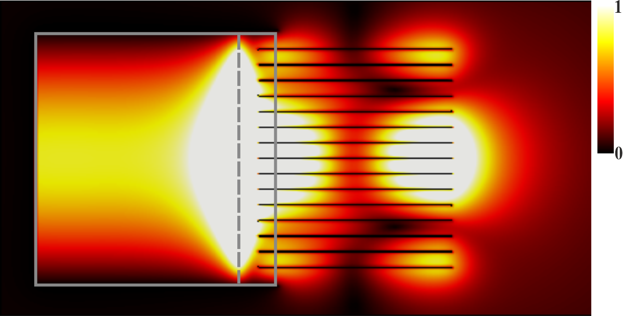
Fig. 1. Example of an image with acceptable resolution.
When your refer to an equation, a figure, a table, a section or literature references in the text of the paper please use the following expressing: Eq. (1), Eqs. (1) and (2); Fig. 1, Figs. 1 and 2; Table I, Tables I and II; Section I, [1], [2].
References must be formatted according to the IEEE citation style.

III. Conclusion
In this paper the instructions for preparing camera ready paper for including in the Proceedings of International Conference PREDT-2025 is given.

IV. References
[1] | C. A. Balanis, Antenna theory: Analysis and design, 4th ed. Hoboken, NJ: Wiley-Blackwell, 2016..
[2] | A. Einstein, B. Podolsky, and N. Rosen, “Can quantum-mechanical description of physical reality be considered complete?,” Phys. Rev., vol. 47, no. 10, pp. 777–780, 1935
[3]

